Craft-Banzi

This README serves to be your guide for the Barrett-Henzi Lab website build in [**Craft CMS**](https://craftcms.com/). This guide will contain information relevant to maintaining and updating the website. The back-end of the website contains comments and information related to specific **entries** and **fields**, but this file provides QuickStart info, and some general information related to the site.

# Keywords and Definitions

* [**Entry/Entries**](https://craftcms.com/docs/3.x/entries.html)**:** A series of related **Fields** responsible for populating a certain template structure within the front-end.
* [**Field**](https://craftcms.com/docs/3.x/assets-fields.html#settings): A single piece of entry data.

For example, **Asset** **Field**s expect an image to be added. In the case of an Asset field, you can add a new asset by uploading a file or selecting an existing asset. Other fields might be plain text, or checkboxes.

* **Section:** Sections are closely related to entries and refer to a given portion of the front-end. Sections have a corresponding entry type which is filled out in order to add additional content to that section.

# Front-End

The front-end of the website (what a user sees when they visit the website in their browser) consists of three main pages. These pages **Home/Index**, **Publications**, and **About** are templates (blank-slate structures) which are populated by **entries** which can be added, modified, or removed in the back-end. The front-end will dynamically respond to any changes made to the back-end and adjust the structure accordingly. This means that modifications to the template code that comprises the website is not required in any way.

Figure 1: The front-end of the website's landing page

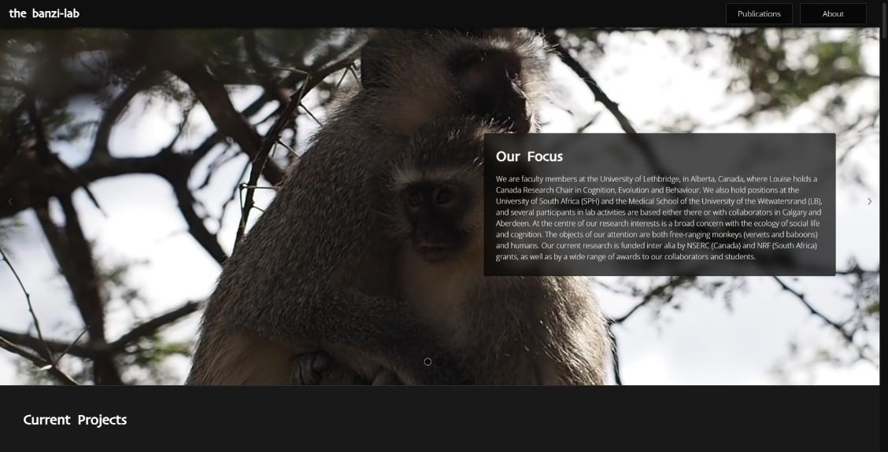

# Back-End

The back-end is what is responsible for modifying content on the site. The back-end is reached by navigating to /admin and logging in using username and password. Once logged in, you will find a series of tabs which are used to manage content.

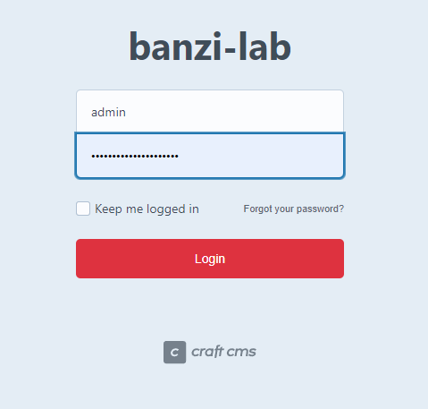

Figure 2: The back-end login

# Back-end Tabs, Navigation, and Overview

## Dashboard

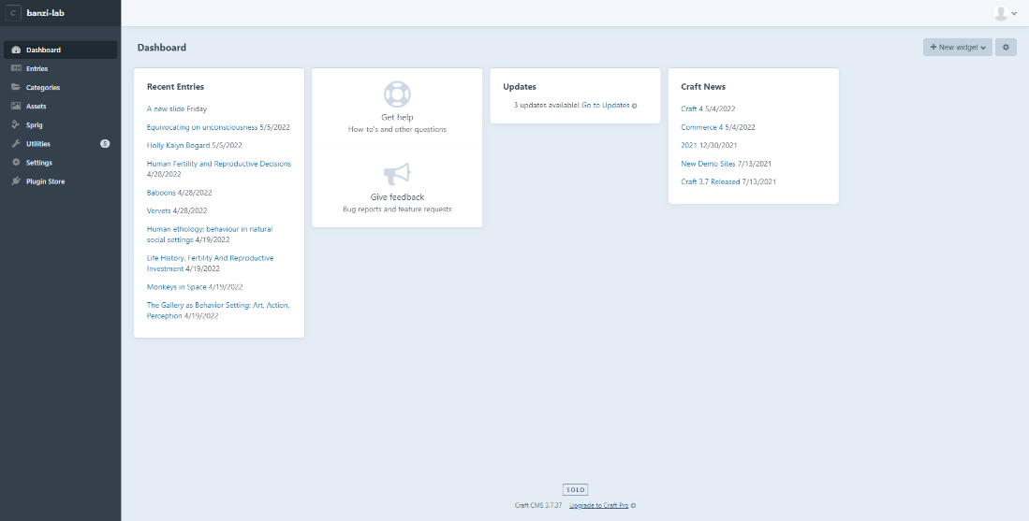Contains a list of recent entries, optional updates, and news regarding Craft CMS.

Figure 3: The back-end dashboard.

## Entries

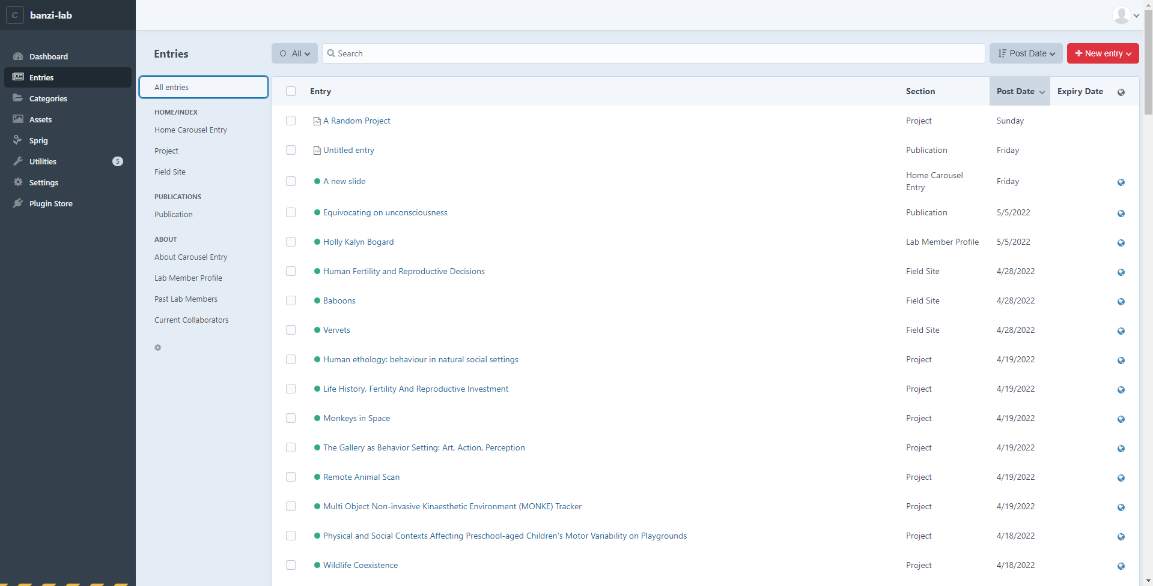The **Entries** tab is where the majority of content management will happen. This tab contains several entry structures, each of which is responsible for rendering a certain **section** or content element. **Entries** are organized by the page that they are used to populate (Home/Index, Publications, and About).

Figure 4: The back-end Entries tab.

More information on the specific entry types can be found below in the ***Content Management*** section of the README.

## Categories

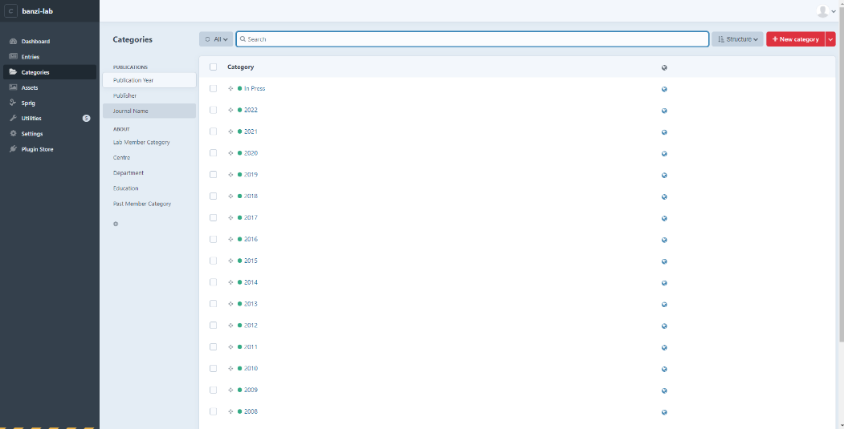There are several categories within the site that perform various functions related to the content, including controlling content ordering, and reducing user input repetition. Certain fields will ask for a category to be added. You can select an existing option from the category or add a new category.

Figure 5: The back-end Categories tab.

**Note:** Spelling and capitalization matter here, so ensure that a category does not already exist with different capitalization/spelling before adding a redundant category.

### Categories include:

#### Publications

* **Publication Year:** A year that a publication is published. Also includes an "In Press" category.

**Note:** Adding a Publication Year category will add a new section (denoted by the year header) to the **Publications** page front-end (and update the nav dropdown menu) that contains all publications that fall under that **Publication Year** category. Order of the categories within the back-end is important. More recent years should appear at the top of the list of **Publication Year** categories to enforce the descending order of the publications (i.e., more recent publications appear at the top of the page). You will also need to ensure that the *In Press* category is always at the top of the **Publication Year** category list to ensure that it always appears first.

* **Publisher:** Category refers to various publishers who publish the lab's publications.
* **Journal Name:** The name of a journal where a paper might be published.

#### About

* **Lab Member Category:** Categories related to what role/position is held by lab members (e.g., Master's Student, Research Assistant, etc.)

**Note:** Adding a **Lab Member Category** will add an additional section to the **Lab Members** portion of the About page (and update the nav button dropdown menu) given that at least one Lab Member entry exists that falls under that category. Lab Member category order within the back-end can be modified (see **Drag and Drop**) to adjust the order of the Lab Member sections on the About page.

* **Centre:** Refers to a university or equivalent institution.
* **Department:** A department (e.g., Psychology) within a **Centre**.
* **Education:** The highest education that a Past Lab Member has achieved.

e.g., PhD, MSc.

* **Past Member Category:** Categories that make up the **Past Lab Member** section of the About Page.

**Note:** Order of these categories within the back-end is important and modifying it (drag and drop) will change the order that content is rendered in the front-end.

## Assets

All assets (images) that have been directly uploaded to the back-end. Images that are uploaded to an entry may not appear here.

## Sprig

Sprig is the plugin responsible for dynamic rendering of content blocks within the site. This tab includes a Sprig coding 'playground' to test code snippets for development. For the most part you should not need to interact with this tab.

## Utilities

Contains System info, Database Backup, and more. Typically, nothing should need to be done within this tab. If more information is required regarding **Utilities**, [here is the Craft documentation pertaining to it](https://craftcms.com/docs/3.x/extend/#modules-vs-plugins).

## Settings

Various CMS settings related to System and Content. This is where the structure of **Fields** and **Sections** can be modified, and routes can be added.

Generally speaking, settings should not need to be modified, and should not be unless you know what you are doing.

## Plugin Store

Find and add new plugins to the CMS. In general, Plugins should be avoided and should not be installed unless they receive adequate support and have no system vulnerabilities.

# Content Management

Managing content in a Content Management System (CMS) like ***Craft CMS*** is straightforward and easy and does not require any modifications to be made to the front-end template code at all. All modifications and additions to content can be done from the back-end with no programming or web development knowledge.

To manage the CMS through adding, modifying, or removing content, you must ensure that you are signed into the back-end by navigating to /admin and entering the username and password for the admin account. **All content management steps assume you have logged in**.

## Entries and Entry Types

Most content management is related to adding, modifying, and removing entries. Each section of the website that has dynamic content (content that can be modified or added to i.e., pretty much all of it) has a corresponding **Entry** type that is responsible for the content that users interact with in the front-end when visiting the site in their browser. This section will include some examples demonstrating how a back-end entry will translate into a piece of front-end content.

**These entry types include the following:**

### General

General entry types that are not featured on a specific page or in a specific section.

#### Default Publication Image

* The **Default Publication Image** entry is a simple single field entry type that accepts an image asset that is used as the **Publication** cover image in cases where no cover image is uploaded to either the **Journal Name** category's **Default Publication Cover Image**, or specific **Publication** entry's **Publication Cover Image** field.

### Home/Index Page

Entry types that are responsible for rendering content on the **Home/Index** page.

#### Home Carousel Entry

* Each **Home Carousel Entry** is responsible for a single slide found in the carousel at the top of the **Home** page. The first entry in the **Home Carousel** is likely the first thing that a user will see when they visit the site, and as such should be reserved to a **Home Carousel Entry** like *Our Focus* which describes what the lab does generally.

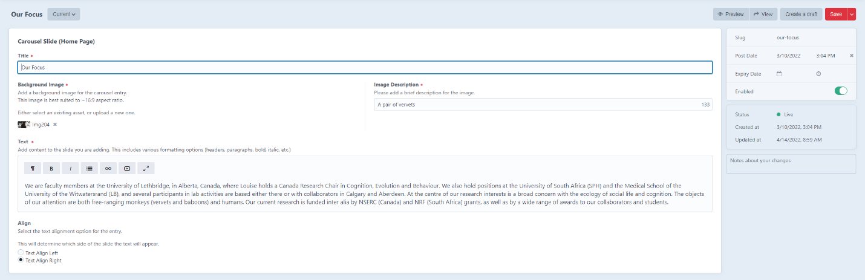Other uses for this entry type could be News and Events related to the lab, like important conferences/talks being given by a lab member.

Figure 6a: An example of a back-end Home Carousel Entry.

Figure 6b: Home Carousel Entry front-end content generated from the above entry.

#### Project

* 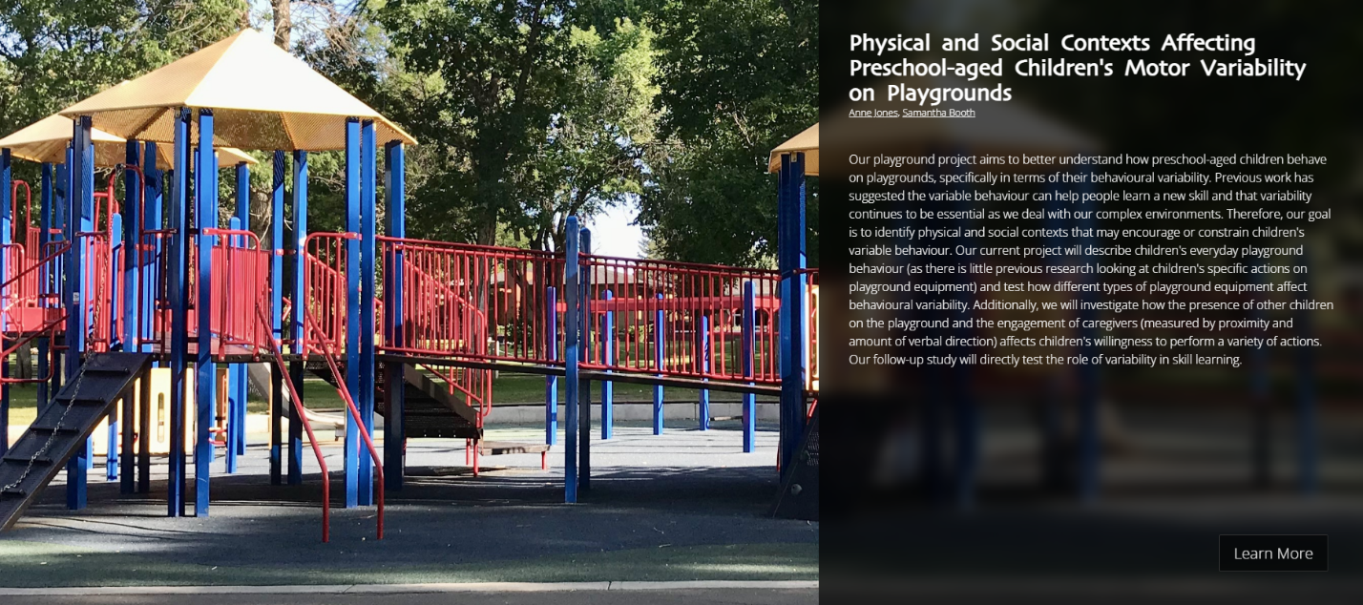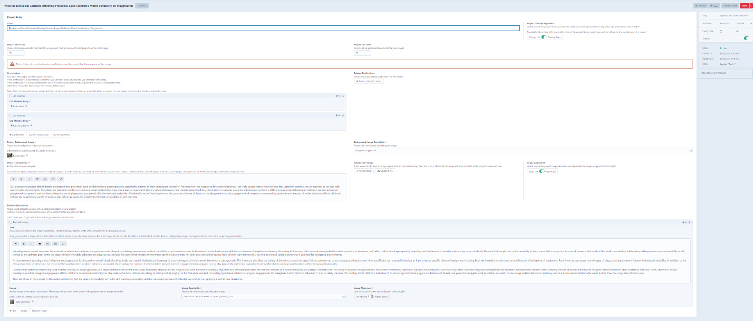Each **Project** entry is responsible for rendering a single project that someone in the lab is working on. These entries appear towards the top of the **Home/Index** Page.

Figure 7b: Project front-end content generated from the above entry (minimized view).

Figure 7a: An Example of a back-end Project entry.

#### Field Site

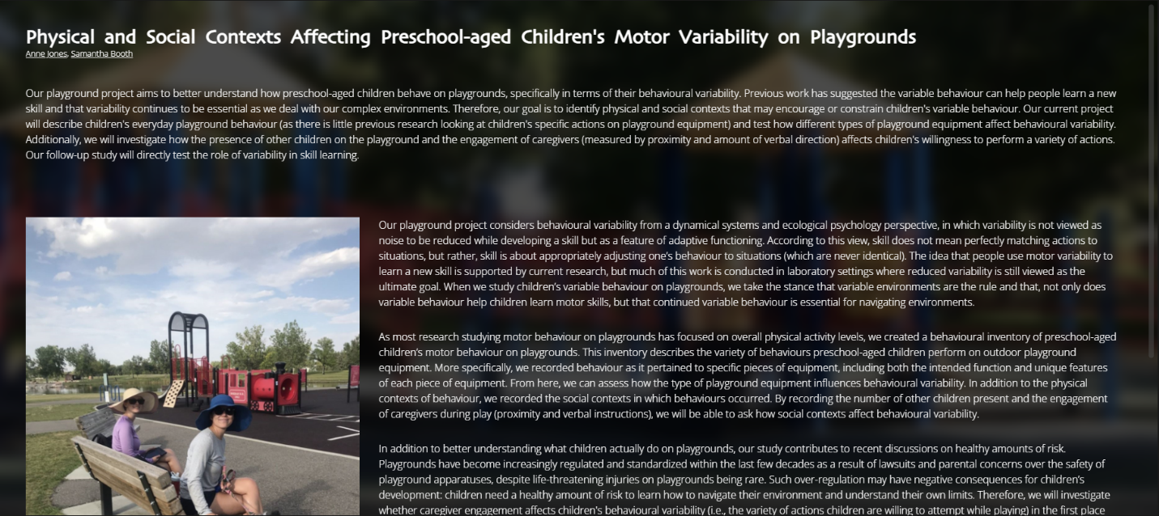

Figure 7c: Project front-end content generated from the above entry (expanded view).

* **Field Site** entries share a very similar structure to **Project**s. Each **Field Site** entry renders a single field site, which will be located at the bottom of the **Home/Index** Page

Figure 8a: An example of a back-end Field Site entry.

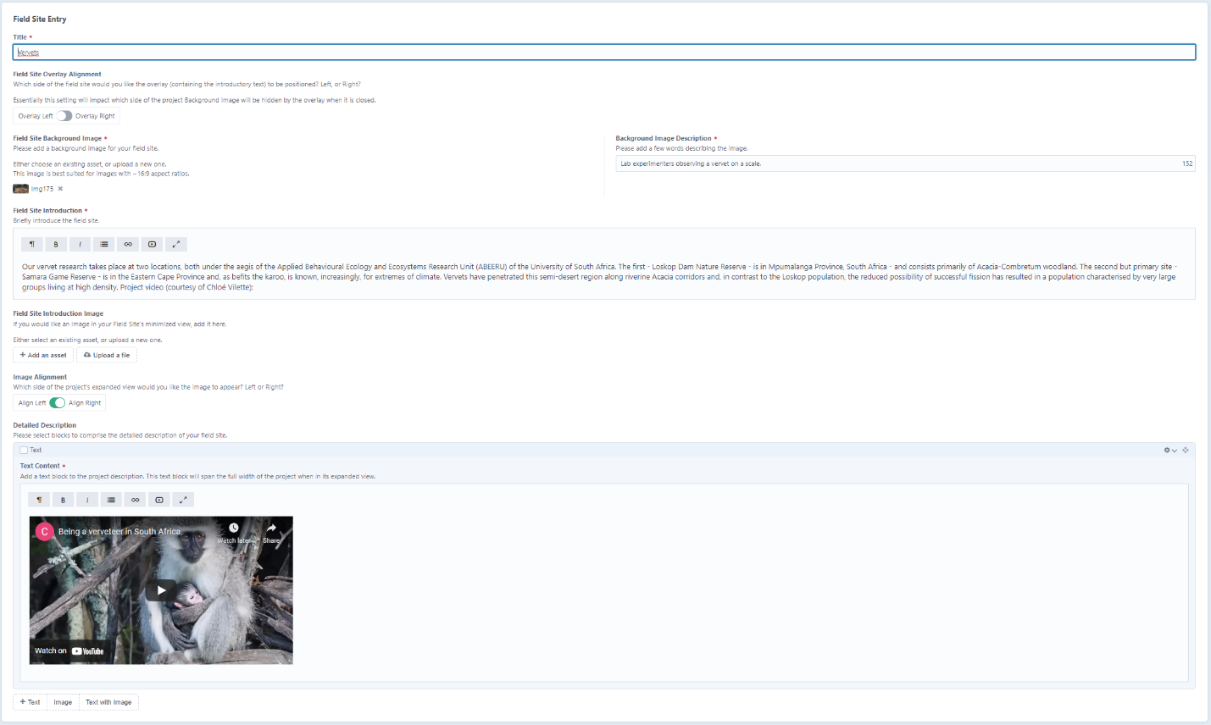

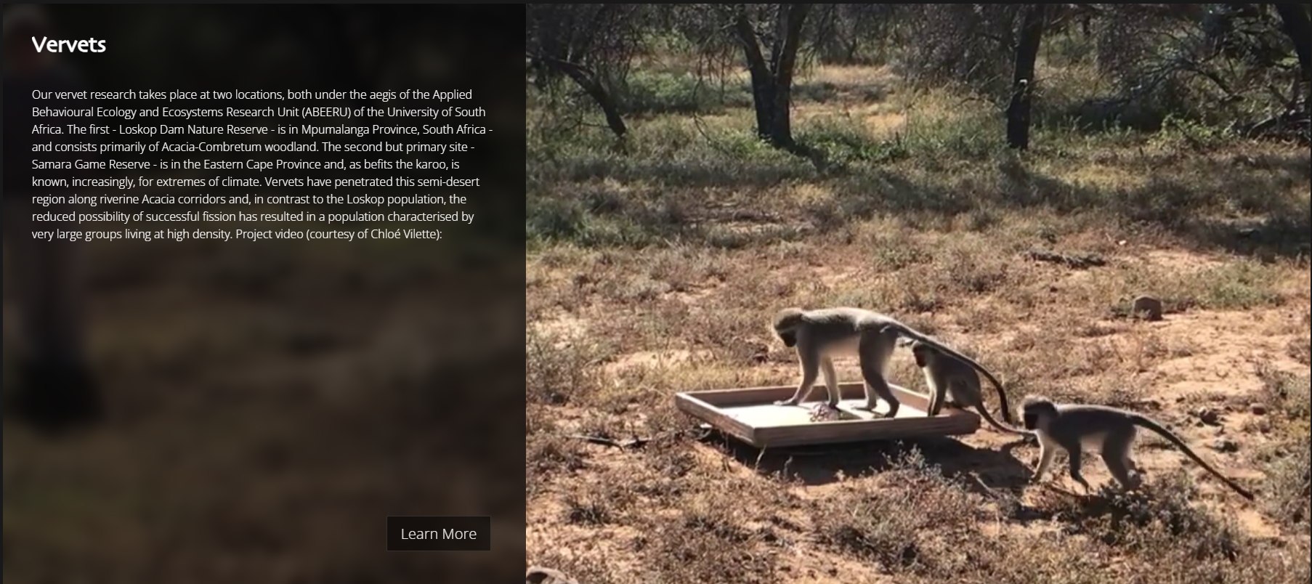

Figure 8b: Field Site front-end content generated from the above entry.

### Publications Page

Entry types that are responsible for rendering content on the **Publications** page.

#### Publication

* 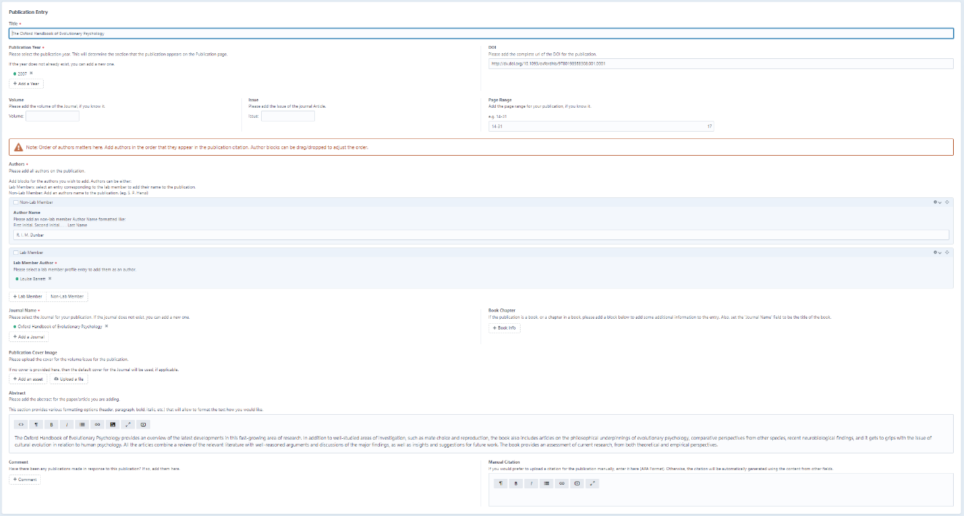Each **Publication** entry is responsible for a single publication found on the **Publications** page.

Figure 9a: An example of a back-end Publication Entry.



Figure 9c: Publication front-end content generated from the above entry (expanded view).

Figure 9b: Publication front-end content generated from the above entry (minimized view).

**Note:** Citations for publications are automatically derived from the fields within a **Publication**. If you prefer to add a manual citation, you can use the **Manual Citation** field in the Publication entry to override this feature.

**Publication**s will be ordered based on the **Publication Year** category selected for the entry, with most recent **Publication Years** appearing at the top. Keep in mind that **Publication Year** order can be modified if needed to enforce this rule. See ***Modifying Section Order*** below. Within a **Publication Year**, entries will be ordered based on the order they are found within the **Publication Entries** section of the back-end, with the most recent entries (those appearing at the top of the list) appearing first.

### About Page

Entry types that are responsible for rendering content on the **About** page.

#### About Carousel Entry

This entry type follows the same structure found in **Home Carousel Entry**, the difference being the carousel where it is found. These entries are responsible for a single slide found in the carousel at the top of the **About** page.

Uses for this entry include things like lab related news and activities that are open to the public.

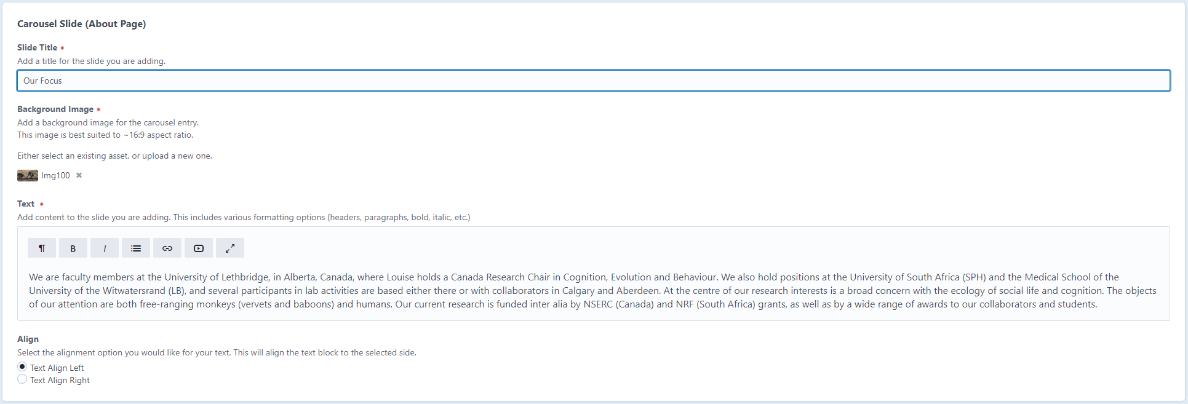

Figure 10b: About Carousel Entry front-end content generated from the above entry.

Figure 10a: An example of a back-end About Carousel Entry.



#### Lab Member Profile

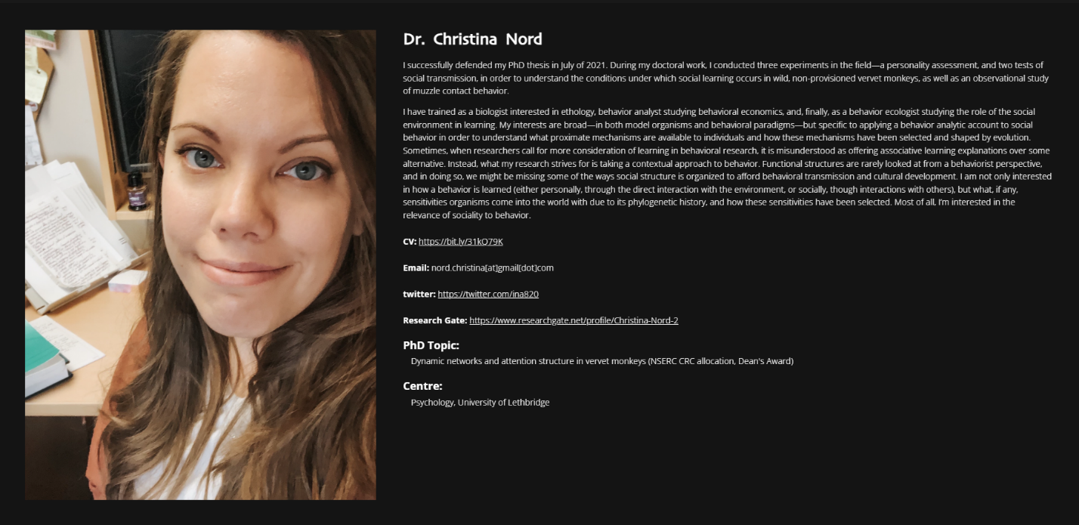Each **Lab Member Profile** entry is responsible for rendering a single lab member profile block found within the **About** page.

Figure 11b: Lab Member Profile front-end content generated from the above entry

Figure 11a: An example of a back-end Lab Member Profile entry.

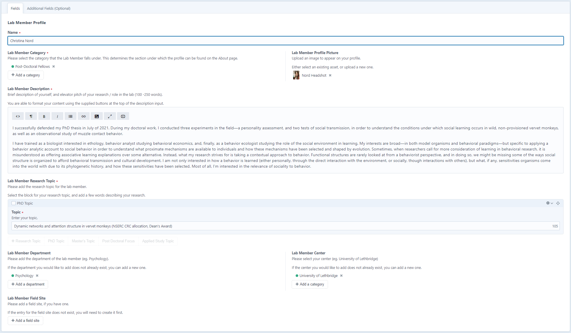

**Lab Member Profiles** are first ordered by the **Lab Member Categories** List, with the categories at the top of the list appearing at the top of the page. Within a **Lab Member Category**, **Lab Member Profile** entries are placed in the order that they are found in the **Lab Member Profile** entry eist, with entries at the top appearing first.

**Note:** In the above example (**Figure 11a**) there is an additional tab at the top of the entry form, which has additional fields which support certain edge cases that lab members may want to take advantage of in their profiles.

**e.g.,** The *Preferred**Citation Name* field exists in case the automatic citation generated by the system does not accurately reflect the citation name appearing in your publications.

#### Past Lab Members

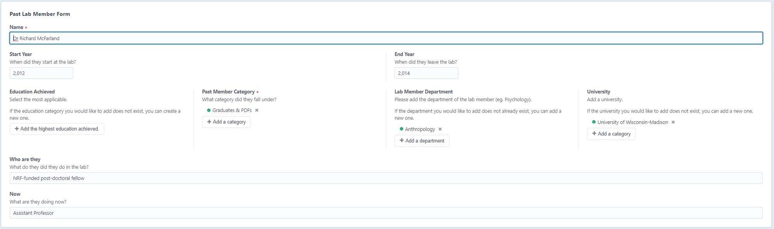Each **Past Lab Member** entry renders a list item within the **Past Lab Member** section of the **About** page.

Figure 12b: Past Lab Member front-end content generated from the above entry.

Figure 12a: An example of a back-end Past Lab Member entry.

Past Lab Members are first ordered by the **Past Member Category** order, with categories at the top of the list appearing first. Within a **Past Member Categor**y, entry order is determined by the order they are found in the **Past Lab Members** entry list.

#### Current Collaborator

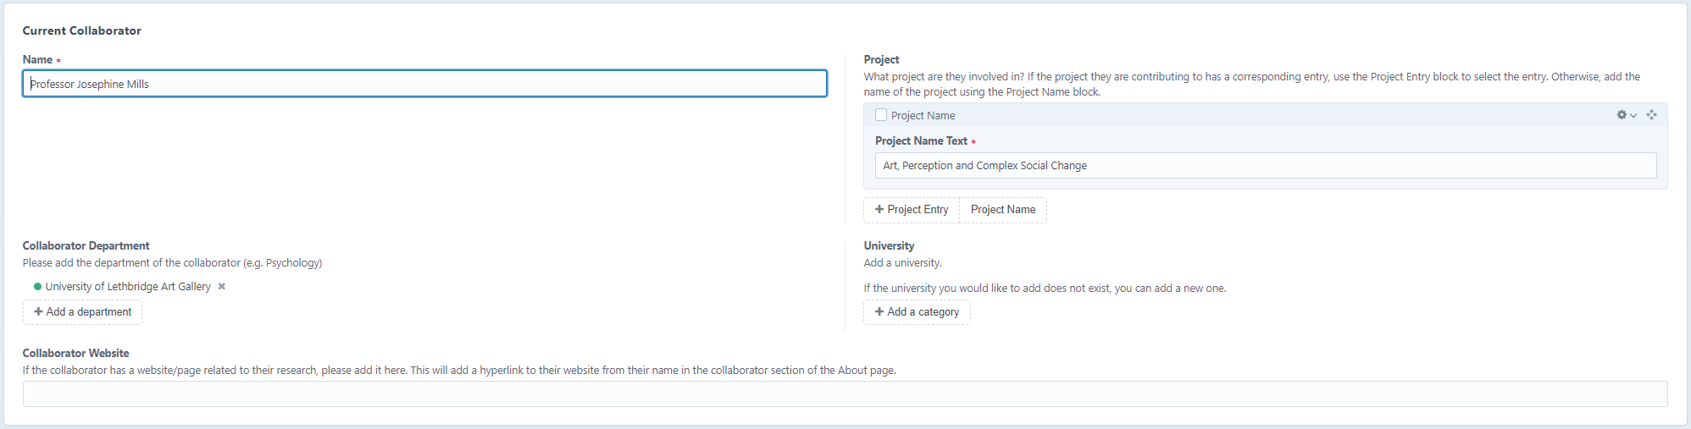Entries for anyone currently working with the lab on a project/publication, but who is not a full-fledged lab member.

Figure 13b: Current Collaborator front-end content generated from the above entry.

Figure 13a: An example of a back-end Current Collaborator entry.

**Current Collaborator** order is determined by the order the entries appear in the back-end, with entries at the top of the list appearing first.

Adding Content

Adding content to the site is very straightforward. To add some content, follow these steps:

1. Navigate to the **Entries** Tab in the back-end.
2. Select the type of entry you would like to add.
   1. Along the left-hand side of the entries panel, choose the header of the entry type you wish to add.
   2. Once selected, all existing entries of that type will be shown.
   3. At the top right, click the red button **+ New Entry** to create a new entry of that type.
   4. **Alternatively**, you can click on the dropdown arrow next to the **+ New Entry** button and select the type of entry you want to add from the dropdown list.
3. Fill out the entry form completely, ensuring that all fields indicated with a **\*** are filled out. If the entry is not entirely filled out, it cannot be added the site. Incomplete entries will be placed in a draft state, and you can always come back to finish it later.
4. Once the entry has been filled out, select the red **Create Entry** button at the top right.
   1. The dropdown next to the **Create Entry** button also provides additional options for the entry and may improve workflow.
5. You must also ensure that the entry is *enabled* for it to appear on the live site. See **Disabling Content (temporary content hiding)** below.

### Additional Content Creation Tips

Here is some additional information to help with your content creation workflow.

#### Previewing Entries

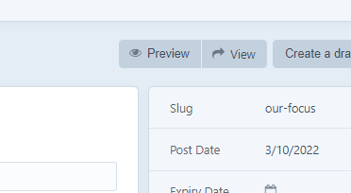In Progress entries can be viewed in real time by clicking on either the **Preview** button (opens the entry within the editing window), or the **View** button (opens the entry in a new tab).

Figure 14: Preview/View buttons found within the entry editing panel.

**Note:** Certain entries that load dynamically may not work correctly when using the live preview.

#### Entry Expiration

Sometimes you would like to create an entry that will automatically be disabled after a certain amount of time, for example Carousel entries related to events that will end on a certain day, and talking about them on the site would not make sense after that day. Fortunately, this feature is built in and can be used easily.

When creating an entry, an **Expiry Date** option can be found on the right-hand side. Select a date and time in this field, and when that time/date is reached, the entry will be automatically **disabled**. Expired entries are labeled with a **red circle** next to the entry.

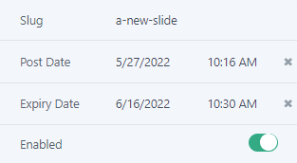

Figure 15: Expiry Date optional field.

#### Version Control for Entries

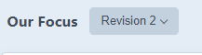Each time an entry is modified, a past version of it is cached by the system in case you make a mistake and would like to revert an entry to a previous version. To view previous versions of an entry, first navigate to the entry’s editing panel. You can then select previous versions of the entry from the dropdown menu that can be found next to the entry’s title near the top of the page.

Figure 16: Entry version control dropdown menu.

Once a previous version of the entry has been selected from the dropdown, the fields of the entry will automatically be repopulated with the previous content. These fields **cannot be modified when viewing a previous version**.

To revert the content of an entry to a previous version, select the button at the top right labeled **Revert content from this revision**.

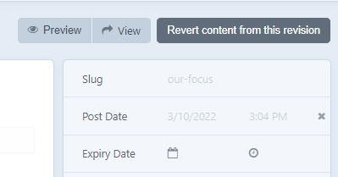

Figure 17: The Revert content from this revision button can be found at the top right of an entry after selecting a revision version from the dropdown.

### Entry Fields

Most fields within an entry are straightforward and have instructions above them. However, certain fields are a little more complex including:

* **Matrix Blocks:**

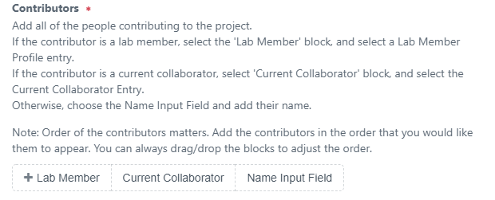**Matrix Blocks** allow you to select from a variety of pre-set content blocks and choose the one best suited for your needs or use case.

Figure 18a: Matrix Block field featuring Lab Member, Current Collaborator, and Name Input Field block types.

For example, when adding project contributors, you can choose from three options (Lab Member, Current Collaborator, and Name Input Field) to add as a contributor to the project.

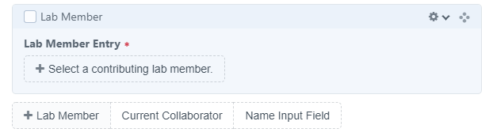

Figure 18b: Lab Member Matrix block type after selecting Lab Member in Figure 18a's matrix.

After choosing an option from the matrix, you will be given a block to fill out based on your selection.

In some cases, you may have the option to add multiple blocks from a matrix, depending on the situation. You may need multiple blocks for your content, and in some cases, the order of the blocks matters. In the example above, the order of the blocks determines the order that the project collaborators will be added to the project. If you make a mistake, or need to adjust the order, you can drag/drop the blocks to modify the order.

* **Assets:**

Either **Add an asset** (that already exists in the back-end) or select **Upload a file**, which will prompt you to choose an asset to upload from your computer. Image assets will automatically be sized to fit within the front-end. You do not need to worry about properly sizing images, the system will handle the image scaling on its own.

Depending on where the image will appear, it may be sized differently. For example, the images uploaded to the **Project Background Image** field will fill the entire width of the project panel and will overflow if necessary to avoid distorting the image. Images in this case also have a parallax effect attached to them which will introduce additional cropping on the top and bottom of the image. Conversely, **Lab Member Profile Picture** images will size themselves relative to the size of the content that they appear next to but will not exceed the intrinsic dimensions of the image (i.e., if the image is 500x500 pixels, it will not grow to 900x900 pixels, becoming large and blurry to fill the space). Any image sizing of this nature is intended. Sometimes, images will need to be cropped/resized prior to being uploaded to achieve the desired result.

Modifying Entry Content

Modifying content is just as easy as adding new content. To modify an existing entry, simply select the entry you wish to edit and adjust the fields within. Please ensure to save your changes by clicking the **Save** button at the top right of the entry.

* Content within Matrix blocks can be changed and blocks themselves may be re-ordered (drag and drop) or removed entirely.
* Images can be replaced by simply uploading a new image to the asset field.

Modifying Entry Order

Modifying the order that entries appear within a section is as easy as dragging and dropping the entries in the back-end into a new order. Unless otherwise noted in the **Entries and Entry Types** section, entries are displayed in the front-end in the same order they appear in the **Structure** list in the back-end.

When in the back-end, ensure that entries are sorted in **Structure** order by selecting the entry sort button at the top right, and selecting **Structure**.

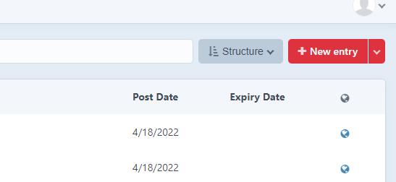

Figure 19: The entry sort dropdown menu, which can be used to select Structure to drag and drop entries to modify the order of the entries.

This displays the entries in a list in the same order that they will appear in the front-end. When sorted by **Structure**, entries can be **dragged and dropped** into a new order which will subsequently change the order that entries will appear on the live site.

Modifying Section Order

Section order is controlled by the order of the categories associated with entries on a given page. For example, the **About** page displays the **Lab Members** sections based on the order of the **Lab Member Category** associated with each **Lab Member** entry.

To modify the order that sections appear in the front-end, select the Categories tab on the left side of the admin page. Then find the category governing the order of the sections you wish to modify (described above in **Entries and Entry Types** section) and click it to view those categories. Sort the categories by **Structure** by clicking the sorting button at the top right. Categories can now be re-ordered by dragging and dropping them into new locations within the list.

Removing Content

Removing content in Craft CMS is simple. All elements within the CMS (entries, categories, matrix blocks follow the same basic steps to be removed from the CMS. CMS elements can be **deleted**, which will **permanently remove them from the website**, or they can be **disabled** temporarily and re-enabled at a later date.

Deleting Content

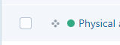Content Elements are **deleted** by navigating to the appropriate tab on the /admin page, and selecting each element you wish to delete with the checkbox on the left side of the element.

Figure 20: Checkbox used to select multiple entries for deletion.

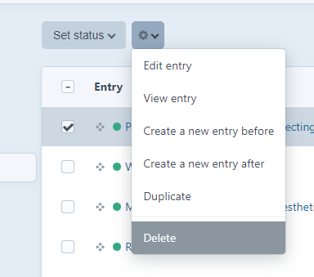Once any number of elements are selected, they can be permanently deleted by selecting the gear icon at the top of the page and selecting **delete**.

Figure 21: Interface demonstrating deletion.

### Disabling Content (temporary content hiding)

Content elements can be disabled temporarily at any time by navigating to the element you wish to disable and clicking to edit the element. Once inside the editing interface, you will find a switch to disable the element on the right-hand side.

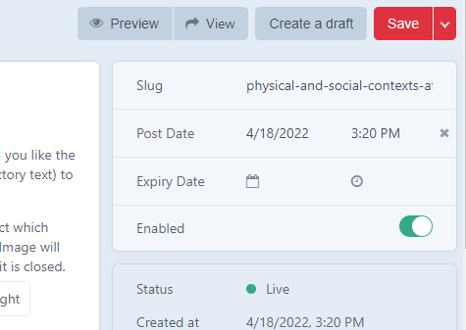

Figure 22: Switch found in the entry editing panel that can be used to enable/disable the entry.

Alternatively, you can disable multiple elements at the same time by navigating to the entries section you wish to modify and selecting multiple elements with their checkboxes on the left side of the entry list and clicking **Set Status** and choosing to enable/disable.

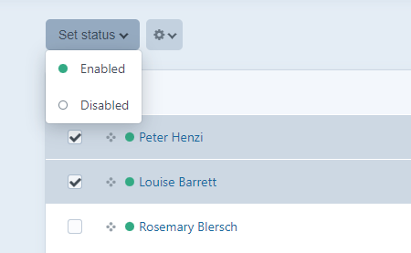

Figure 23: Enabling/disabling multiple entries through the Set status dropdown.

When disabled, the element will still exist in the database but will not be visible in the front-end of the site. Disabled elements can be re-enabled by clicking their enable/disable switch again.

You can tell which elements are enabled/disabled at a glance by the circle on the left-hand side of the element. When the circle is green, that element is visible in the front-end of the live site. When the circle is empty, the element is disabled.

# More Useful Information and Tips

This section contains several helpful tips related to the content management workflow.

Drag and Drop

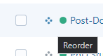**Drag and Drop** functionality for entries, categories, and matrix blocks can be used by left clicking and holding on the *four-dots* icon and moving the element to a new location and releasing the left click where you would like the element placed.

Figure 24: The four-dots icon that allows drag-and-drop to reorder content.